**Project Report: Amazon Clone**

**1. Introduction**

**1.1 Project Overview**

* The Amazon Clone project is a web application that replicates the user interface and design of the Amazon website. It aims to provide users with a familiar online shopping experience similar to Amazon.

**1.2 Objectives**

* To create a visually appealing and responsive clone of the Amazon website.
* To practice HTML and CSS skills by replicating a real-world website.
* To showcase the ability to design and structure a complex web page.

**2. Technologies Used**

**2.1 Front-End Technologies**

* HTML: Used for structuring the web page.
* CSS: Used for styling and layout.

**2.2 Development Tools**

* Visual Studio Code (Code Writing/ Editing)

**2.3 External Libraries**

* Font Awesome: Used for icons in the user interface.

**3. Project Structure**

**3.1 HTML Structure**

* The project's HTML is structured into header, hero section, shop section, and footer.

**3.2 CSS Styling**

* CSS is used extensively to style and format the various elements of the Amazon Clone.



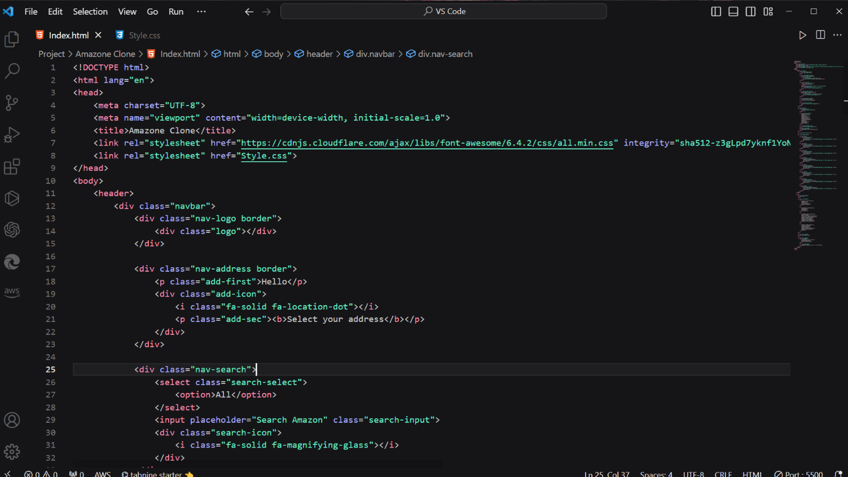



**VS Code**

**4. Key Features**

* Navigation: The header contains navigation links similar to Amazon.
* Search Bar: Users can perform searches using the search bar.
* Product Categories: The shop section displays various product categories.
* Responsive Design: The project is designed to be responsive and work on different screen sizes.

**5. User Interface Design**

* Color Scheme: The project uses a color scheme reminiscent of Amazon's branding.
* Layout: The layout is similar to Amazon's, with a top navigation bar and product grid.

**6. Functionality**

* Navigation: Users can navigate between different sections of the website.
* Search: The search bar allows users to search for products.
* Hover Effects: Border changes on hover for interactive elements.

**7. Challenges and Solutions**

* Styling: Achieving an accurate visual representation of Amazon's design required extensive CSS work.
* Responsive Design: Ensuring the website looks and works well on various screen sizes was a challenge, but media queries were used to address this.

**8. Testing**

* Extensive testing was performed to ensure that all features and styles worked as expected.
* Cross-browser testing was conducted to ensure compatibility with major web browsers.

**9. Deployment**

* The project can be deployed to a web server or hosting platform to make it accessible online.

**10. Conclusion**

* The Amazon Clone project allowed for the application of HTML and CSS skills in a real-world project.
* The project successfully replicates the user interface of Amazon's website.

**11. Future Enhancements**

* Implementing interactivity and shopping cart functionality.
* Adding a backend for user accounts, product listings, and payment processing.

**12. References**

* Font Awesome: <https://fontawesome.com/>

**13. Appendix**

* Include screenshots of the Amazon Clone for reference.
* Provide a link to the live project if deployed.

NOTE: -

This project report outlines the development and design process of the Amazon Clone. It serves as a documentation of the project's objectives, technologies used, challenges faced, and future development opportunities.

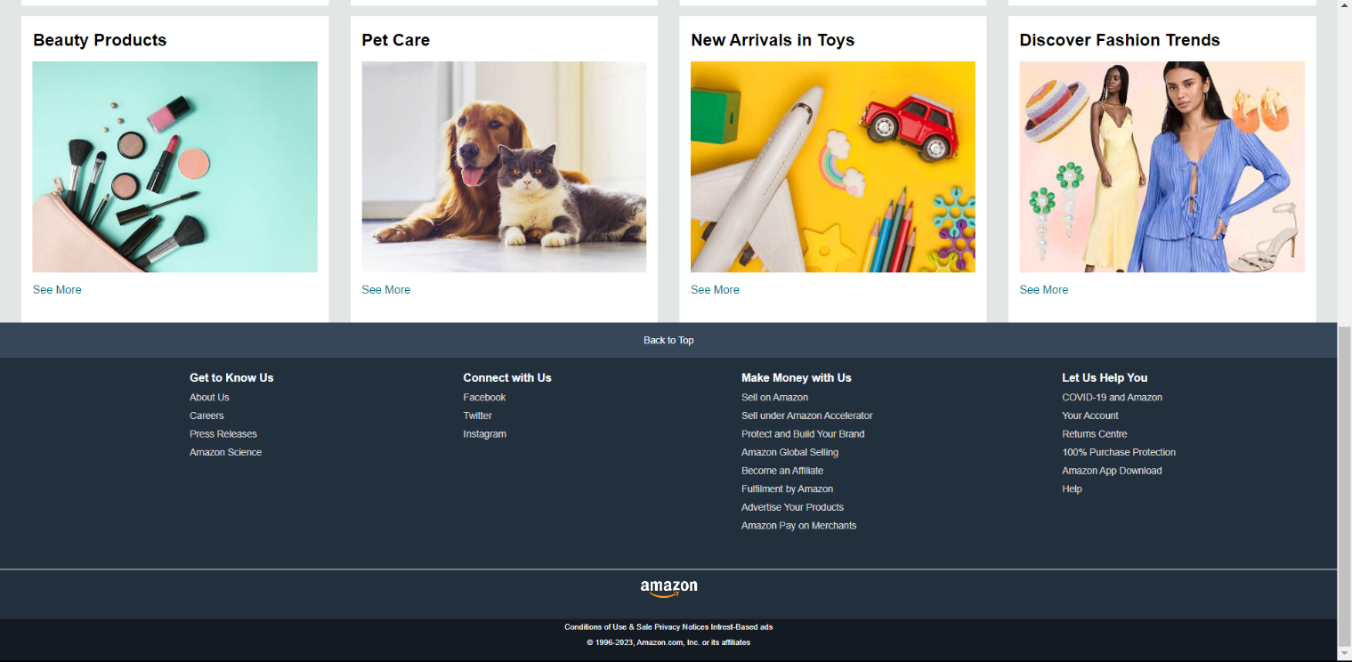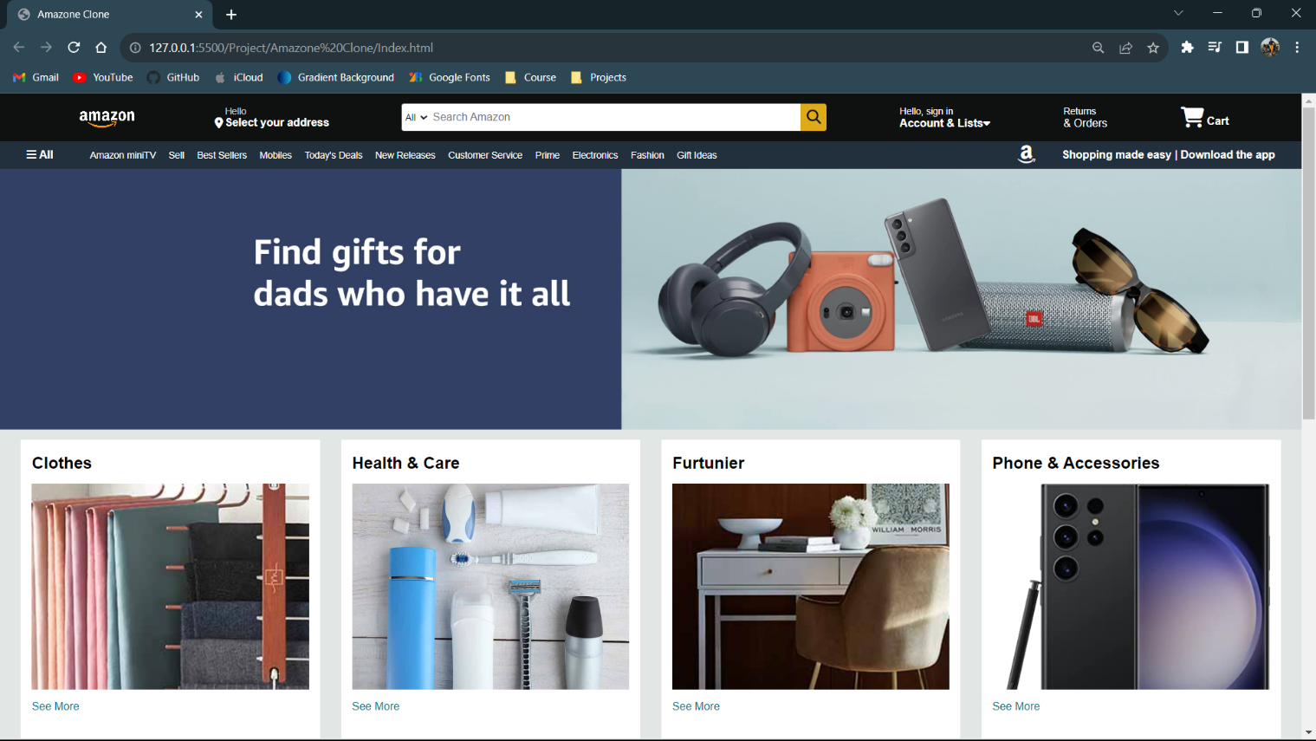WEBSITE FINAL LOOK: